**Translate to multiple languages simultaneously**

**Multi-lingual speech translation**

Multi-lingual speech translation implements a new level of speech translation technology that unlocks various capabilities, including having no specified input language, handling language switches within the same session, and supporting live streaming translations into English. These features enable a new level of speech translation powers that can be implemented into your products.

* Unspecified input language. Multi-lingual speech translation can receive audio in a wide range of languages, and there's no need to specify what the expected input language is.
* Language switching. Multi-lingual speech translation allows for multiple languages to be spoken during the same session, and have them all translated into the same target language. There's no need to restart a session when the input language changes or any other actions by you.
* Transcription. The service outputs a transcription in the specified target language. Source language transcription isn't available yet.

Some use cases for multi-lingual speech translation include:

* Travel Interpreter. When traveling abroad, multi-lingual speech translation offers the ability to create a solution that allows customers to translate any input audio to and from the local language. This allows them to communicate with the locals and better understand their surroundings.
* Business Meeting. In a meeting with people who speak different languages, multi-lingual speech translation allows the members of the meeting to all communicate with each other naturally as if there was no language barrier.

**Multiple target languages translation**

In scenarios where you want output in multiple languages, the Speech service directly offers the ability for you to translate the input language into two target languages. This enables them to receive two outputs and share these translations to a wider audience with a single API call. If more output languages are required, you can create a multi-service resource or use separate translation services.

If you need translation into more than two target languages, you need to either [Create an Azure AI services resource](https://learn.microsoft.com/en-us/azure/ai-services/multi-service-resource) or utilize separate translation services for more languages beyond the second. If you choose to call the speech translation service with a multi-service resource, please note that translation fees apply for each language beyond the second, based on the character count of the translation.

**Multi-lingual translation with language identification**

In many scenarios, you might not know which input languages to specify. Using [language identification](https://learn.microsoft.com/en-us/azure/ai-services/speech-service/language-identification?pivots=programming-language-csharp#run-speech-translation) you can detect up to 10 possible input languages and automatically translate to your target languages.

The following example anticipates that en-US or zh-CN should be detected because they're defined in **AutoDetectSourceLanguageConfig**. Then, the speech is translated to de and fr as specified in the calls to AddTargetLanguage().

For a complete code sample, see [language identification](https://learn.microsoft.com/en-us/azure/ai-services/speech-service/language-identification?pivots=programming-language-csharp#run-speech-translation).

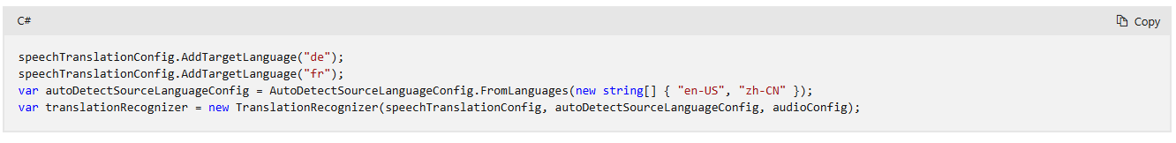

**Multi-lingual speech translation without source language candidates**

Multi-lingual speech translation implements a new level of speech translation technology that unlocks various capabilities, including having no specified input language, and handling language switches within the same session. These features enable a new level of speech translation powers that can be implemented into your products.

Currently when you use Language ID with speech translation, you must create the SpeechTranslationConfig object from the v2 endpoint. Replace the string "YourServiceRegion" with your Speech resource region (such as "westus"). Replace "YourSubscriptionKey" with your Speech resource key.

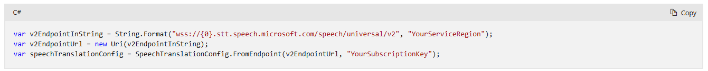

Specify the translation target languages. Replace with languages of your choice. You can add more lines.



A key differentiator with multi-lingual speech translation is that you do not need to specify the source language. This is because the service will automatically detect the source language. Create the AutoDetectSourceLanguageConfig object with the fromOpenRange method to let the service know that you want to use multi-lingual speech translation with no specified source language.



<https://github.com/Azure-Samples/cognitive-services-speech-sdk/blob/master/samples/csharp/sharedcontent/console/translation_samples.cs#L714>